Position details

Division: Community and City Services
Branch: Community Development
Reports to title: Director of Homes Melbourne
Position No: XXXX
Classification: 6
Financial management $1.3M + per annum (Expenditure);
Total people: NIL

Primary skill pool: Stakeholder Management
Secondary skill pool: Program management; Strategy, Homelessness knowledge

Team context

The purpose of the Homelessness Team is to improve housing outcomes for people experiencing homelessness in the City of Melbourne. This will involve partnering with the homelessness sector, including with the Victorian Government through Homes Victoria, the not-for-profit sector including Community Housing Organisations and homelessness service providers. The Homelessness Team will strive to ensure people have access to safe, high-quality housing, close to jobs and services to ensure Melbourne is safe and inclusive, accessible and affordable, and economically prosperous into the future.

The team will deliver Council’s endorsed Homelessness Strategy to lead a creative and visible program to reduce homelessness in the city. The team will work with neighbouring inner-metro Councils to upscale service co-ordination and strategy development, advocate to the Victorian Government to enable sustained investment into social and affordable housing and essential services to support people who are experiencing homelessness.

Culture and Values

CoM aspires to a culture which is humanistic and encouraging, self-actualising, affiliative and achievement focused. We focus on culture because we know that a constructive culture is good for our wellbeing as well as our ability to deliver high quality outcomes.

We measure our performance against the desired culture using the Human Synergistics tool, the “Organisational Culture Inventory” (OCI).

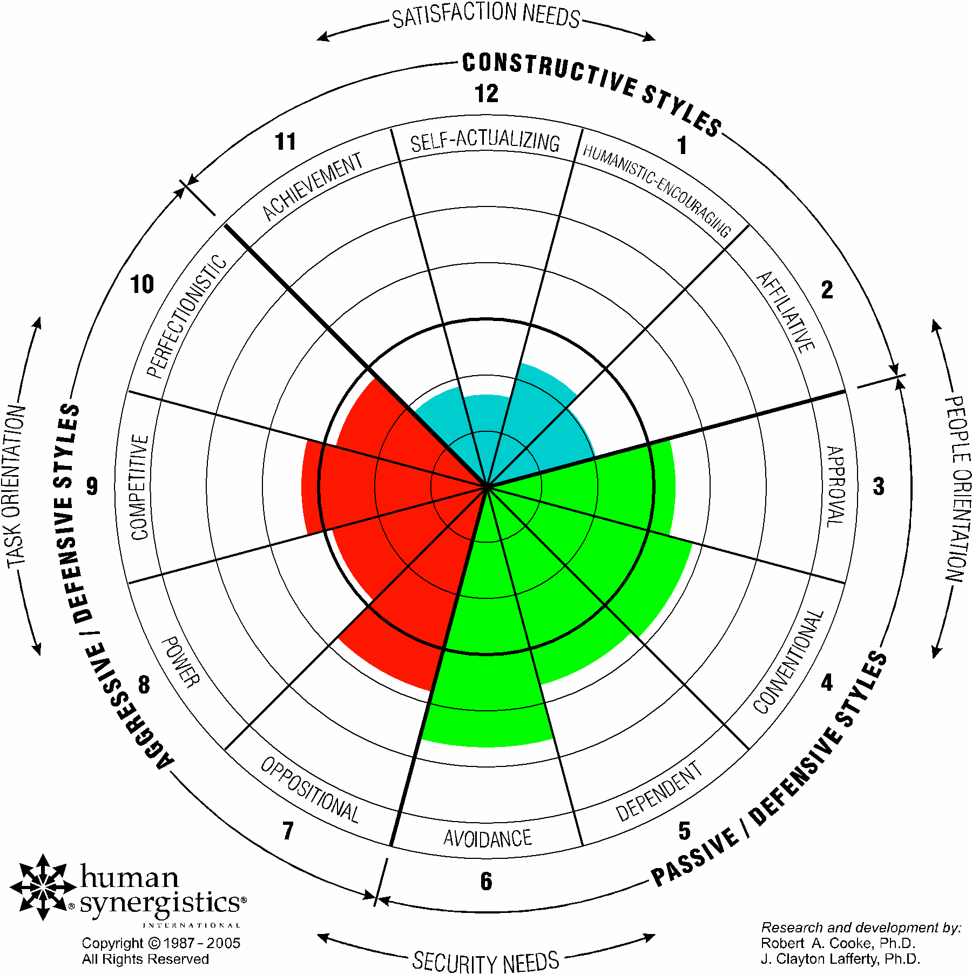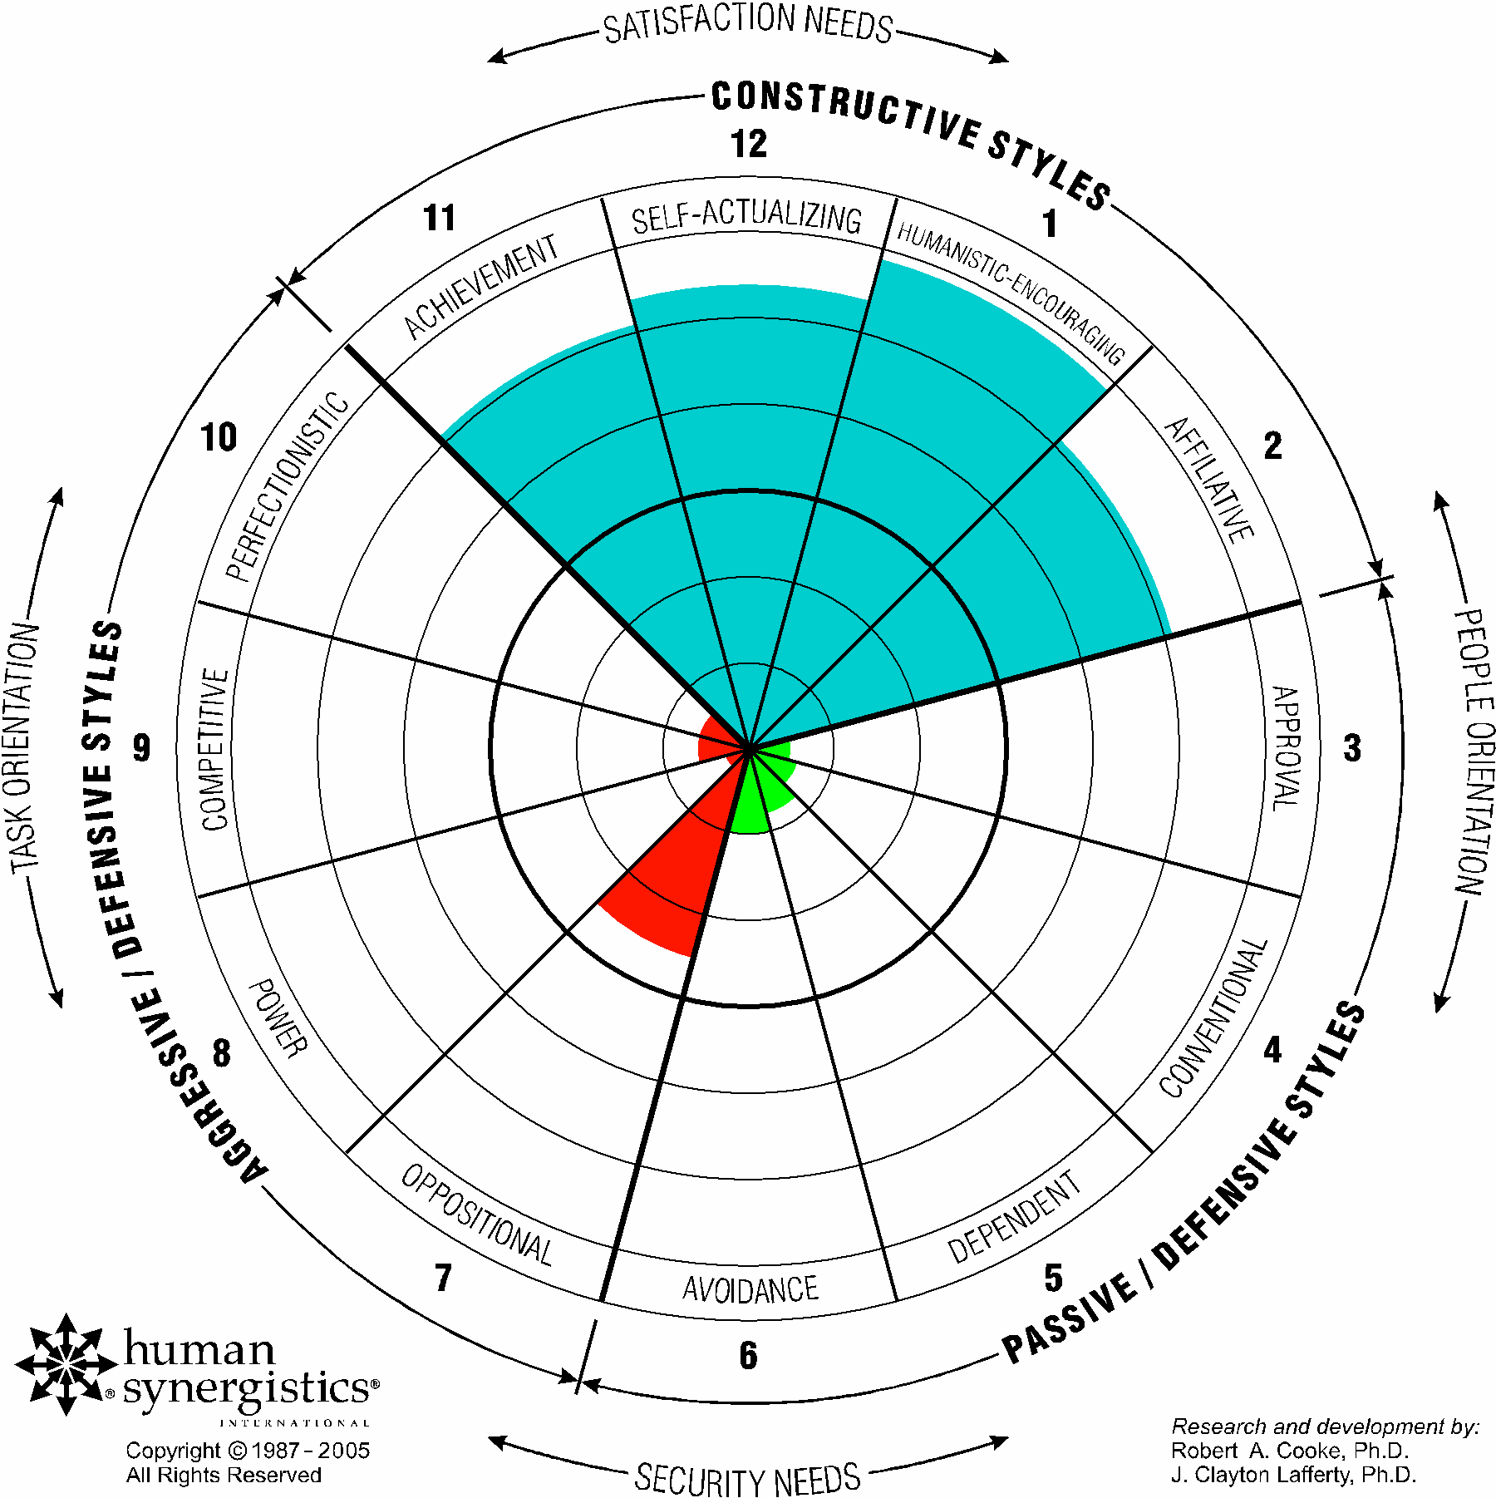

Our ICARE values (integrity, courage, accountability, respect and excellence) are the foundation for our behaviour for ourselves and our teams.

Position purpose

The position is a critical role within the Homelessness Team and will be responsible for creation of formal and informal partnerships within Council, the homelessness sector, residents, businesses other Local Government Areas and State Government agencies.

The Homelessness Partnerships Lead will lead and actively work productively with internal and external senior stakeholders to implement the Homelessness Strategy.

These partnerships will be essential to collating data and providing support to all directorates within Council who have direct or indirect opportunities to prevent or reduce homelessness in the municipality. The role will lead the promotion of homelessness activities and providing training and upskilling to all staff to build awareness, empathy and support.

External partnerships will provide opportunities for greater impact and resource efficiency through advocacy, service provision and aligned strategies. They will maintain an active understanding of key policy issues relating to Homes Melbourne’s strategic purpose and provide expert advice to the executive management team and councillors.

Position accountabilities

Strategic Thinking

- Utilise partnerships and stakeholders to understand current and emerging issues of significance to homelessness, including service contracts, lease agreements and MOUs.
- Coordinate the development and implementation of strategic documents to support partnerships and advocacy efforts
- Coordinate business planning including performance measures, monitoring and reporting processes in line with corporate expectations.
- Provide guidance and support in relation to homelessness issues, projects, policy and activities

Project Management

- Develop and implement project scopes, documentation and manage delivery of partnership projects through to completion
- Ensure project resources, budgets and timeframes are effectively managed
- Measure and evaluate homelessness services to inform future planning
- Identify new project / program opportunities, and review and modify existing programs pertinent to identified issues
- Develop written reports and briefs on behalf of the team as required

Community Engagement and Stakeholder Management

- Engage with State Government, Local Government, peak bodies, homelessness sector services, and private sectors to gain a deep understanding of existing and emerging homelessness issues, gaps within the service sector and opportunities for innovation.
- Leverage external partnerships with government, peak bodies and the homelessness sector to implement the Homelessness Strategy
- Coordinate management of formal partnerships within Council to implement the Homelessness Strategy
- Support community engagement to build awareness, empathy and support
- Develop and maintain effective networks, relationships and partnerships with key internal and external stakeholders

Environment: communication and judgment

Communication:

The position requires the ability to persuade, influence and gain cooperation and assistance from staff, business, stakeholders, government and the community to fulfil project/program objectives. The Homelessness Partnership Lead will need to be confident in communicating and engaging with a range of staff and key decision-makers within and external to the City of Melbourne. To deliver this, the Homelessness Partnership Lead needs highly developed interpersonal, negotiation, analytical and presentation skills.

Judgement:

The Homelessness Partnership Lead exercises autonomy and independence within City of Melbourne’s broad objectives. Accountable for ensuring that the partnerships and stakeholder management meet the strategic goals and desired outcomes related to the Homelessness Strategy. The Homelessness Partnership Lead relies on experience and uses well informed judgement to choose between courses of action that impact not only the work of the immediate team, but more broadly across the organisation and community.

The position is responsible for maintaining appropriate levels of knowledge in relation to social and homelessness matters and emerging issues that may impact.

The Homelessness Partnership Lead will seek the endorsement of the Director of Homes Melbourne for decisions which represent the organisation’s position on key issues and concerns requiring corporate change management.

Selection criteria

- Ability to demonstrate and display City of Melbourne Values – accountability, integrity, courage, respect for self and others, and striving for excellence
- Tertiary degree qualifications in social services/community development, communications / stakeholder management, or extensive experience and knowledge in integrated strategic project planning and the homelessness sector.
- Ability to represent City of Melbourne in meetings with officers in State and Federal Government, high profile stakeholders, community leaders and interest groups and other key bodies.
- Ability to develop and manage strong stakeholder relationships and creation of advocacy positions
- Demonstrated high level project management and service planning skills
- Proven analytical and conceptual skills, and demonstrated experience in solving complex problems
- Demonstrated negotiation, verbal communication and presentation skills in sensitive environments and proven ability to influence positive outcomes
- Highly developed written communication skills as demonstrated by the ability to prepare high standard written reports and submissions to senior decision-makers

Inherent Physical Requirements

The reference to the Inherent Physical Requirements for this position is DM#

The way we work

CoM’s vision is to be a leading organisation for a leading city. CoM fosters a workplace that is stimulating, constructive, flexible, diverse and inclusive and that achieves high quality outcomes for the Council, customers and our community. We recognise that a constructive culture brings out the best in our people. We strive to meet the demands of our employees’ professional lives while they can accomplish their priorities outside of work and have a positive work life balance.

We strive to make our organisation agile, with the ability for our work teams to adapt and change based on the evolving needs of CoM. To keep pace with our customers and our changing city, we need a resilient, adaptable, accountable, diverse and inclusive workforce that reflects our community and is committed to excellence.

We establish challenging but realistic goals, develop plans to reach those goals, pursue them with enthusiasm, and are accountable for their achievement. We want our employees to get enjoyment from their work, develop themselves, and take on new and interesting activities whether they are within CoM or outside of CoM. We want our workforce to be supportive, helpful and open in their dealings with each other, through open communication, cooperation, and the effective coordination of activities.

Commitment to Child Safety
The City of Melbourne (CoM) is committed to being a child safe organisation and has zero tolerance for child abuse. All children and young people are valued members of our community and have the right to be and feel safe. We are committed to embedding child safety into the everyday thinking and practice of all employees, agency staff, contractors and volunteers. We require all CoM employees, agency staff, volunteers and contractors to understand and act to prevent, detect, respond and report any suspicion of child abuse and maintain a culture of child safety and any further responsibilities as required by the

